IMPORT SSL CERTIFICATE(ESB) IN SERVER 55

- Copy SSL Cert ke directory D:\INTERGRASI\JPN\SSLCERT

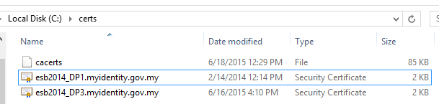

- Copy cacerts daripada java dan masukkan ke dalam D:\INTERGRASI\JPN\SSLCERT

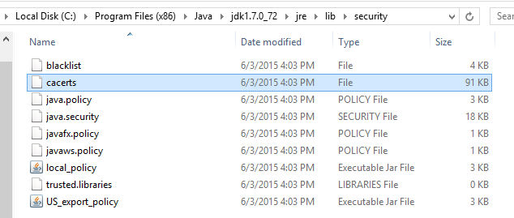

- Run command Prompt as administrator:
cd “Program Files\java\jdk1.6.0_22\bin”
keytool –import –trustcacerts -alias jpndp1 –file D:\INTERGRASI\JPN\SSLCERT \ esb2014_DP1.myidentity.gov.my.crt –keystore D:\INTERGRASI\JPN\SSLCERT \cacerts

Masukkan password apabila diminta
- changeit
- Jika ada error semasa import certificate seperti di bawah :-
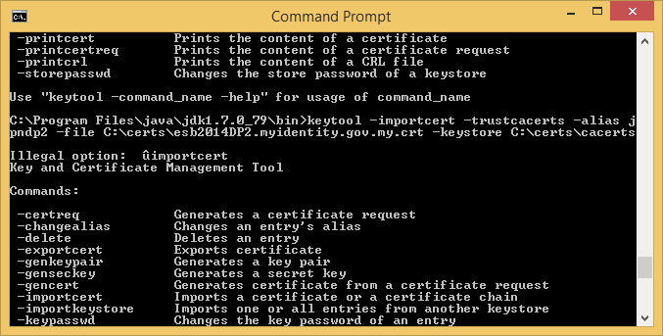

Run keytool dan wsimport as administrator:



- Edit file catalina.bat pada C:/apache-tomcat-7.0.57/bin
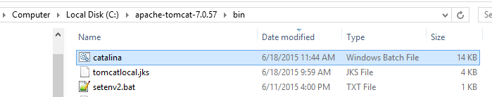

- Tambahkan java parameter tersebut pada LOGGING_CONFIG:

set "JAVA_OPTS=%JAVA_OPTS% -Djavax.net.ssl.keyStore=C:\certs\cacerts"
set "JAVA_OPTS=%JAVA_OPTS% -Djavax.net.ssl.trustStore=C:\certs\cacerts"
set "JAVA_OPTS=%JAVA_OPTS% -Djavax.net.debug=ssl"
set "JAVA_OPTS=%JAVA_OPTS% -Djavax.net.ssl.keyStorePassword=changeit"
set "JAVA_OPTS=%JAVA_OPTS% -Djavax.net.ssl.trustStorePassword=changeit"

